SIMATS ENGINEERING

SAVEETHA INSTITUTE OF MEDICAL AND TECHNICAL SCIENCES
CHENNAI – 602105

Department of Computer Science and Engineering

ASSESSMENT TOOL 1 – Dashboard Development Task

Course Code: | DSA0502 | Course Title: | Query Processing for Data Science
CO  Assessed: | CO5 | Assessment: | Tool 3– Dashboard Development Task
Weightage: | 25% | Total Marks:
CO5 Statement: Create meaningful visualizations using Pandas and Matplotlib, including charts, distributions, relationships, and interactive visual representations for effective communication
Student Name: | Veda Krishnan V A | Reg. No.: | 192324293
Section / Batch: | A 2023 | Date of  Submission: | 31.08.2026
Faculty  In-charge: | K.Veena Devi | Project Mode: | Individual Submission

Choose Any One Task and Create the Dashboard

Student Academic Performance Dashboard
Develop an interactive dashboard using Pandas and Matplotlib to analyze student performance. Import a dataset containing attendance, internal marks, assignment marks, laboratory marks, and final scores. The dashboard should
include bar charts, distribution plots, scatter plots, and frequency charts. Use a scatter matrix to study relationships between variables and identify performance patterns and outliers.

Python Code:
import pandas as pd
import matplotlib.pyplot as plt
from pandas.plotting import scatter_matrix

df = pd.read_csv('student_academic_performance.csv') fig, axes = plt.subplots(1, 2, figsize=(10, 4))
df['Final_Score'].plot.hist(ax=axes[0], title='Final Score Dist', color='skyblue') df.plot.scatter(x='Attendance', y='Final_Score', ax=axes[1], title='Attendance vs Final Score', color='darkblue')
plt.show()
scatter_matrix(df[['Attendance', 'Internal_Marks', 'Final_Score']], diagonal='kde') plt.show()

Generated Dashboard Visualizations:
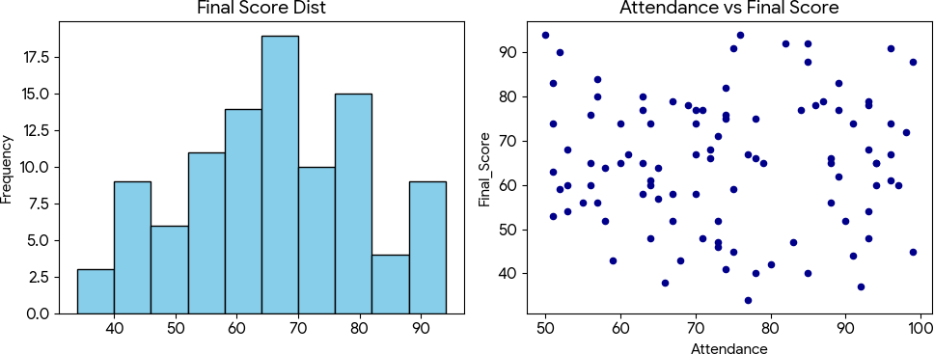

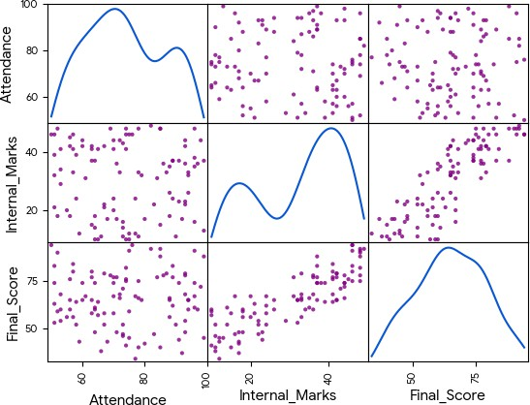

Analysis / Explanation:
The distribution of final scores is visualized in a histogram. The scatter matrix displays strong correlations among internal marks, attendance, and final scores. Outliers can be identified where high attendance did not correlate with high marks.

Sales Performance and Trend Dashboard
Create a dashboard for an e-commerce company using sales data containing date, product, category, quantity, revenue, and region. Analyze the evolution of sales over time, product-wise distributions, and category frequencies. Include appropriate Matplotlib/Pandas plots and use a lag plot and autocorrelation plot to identify time-dependent sales patterns.

Python Code:
import pandas as pd
import matplotlib.pyplot as plt
from pandas.plotting import lag_plot, autocorrelation_plot

df = pd.read_csv('sales_performance.csv') fig, axes = plt.subplots(1, 2, figsize=(10, 4))
df.groupby('Date')['Revenue'].sum().plot(ax=axes[0], title='Sales Over Time') df['Category'].value_counts().plot.bar(ax=axes[1], title='Category Freq') plt.show()

fig, axes = plt.subplots(1, 2, figsize=(10, 4)) lag_plot(df['Revenue'], ax=axes[0]) autocorrelation_plot(df['Revenue'], ax=axes[1]) plt.show()

Generated Dashboard Visualizations:

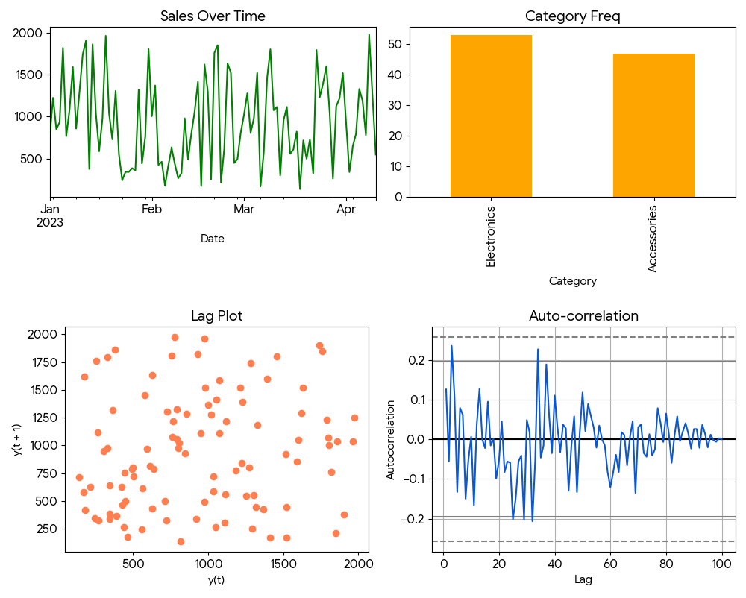

Analysis / Explanation:
Sales evolution is tracked effectively over time, presenting recurring peaks in revenue. The category bar chart showcases product distribution. Autocorrelation and lag plots are useful here to find seasonality or dependence of a given day's sales on prior days.

Employee Productivity Analysis Dashboard
Develop a dashboard to analyze employee working hours, experience, productivity score, salary, and performance rating. Use distributions and frequency plots to understand employee characteristics, scatter plots to identify relationships, and a scatter matrix for multivariable analysis. Identify unusual employee records using suitable visualizations.

Python Code:
import pandas as pd
import matplotlib.pyplot as plt
from pandas.plotting import scatter_matrix

df = pd.read_csv('employee_productivity.csv') fig, axes = plt.subplots(1, 2, figsize=(10, 4))
df['Productivity_Score'].plot.hist(ax=axes[0], title='Productivity Dist') df.plot.scatter(x='Working_Hours', y='Productivity_Score', ax=axes[1]) plt.show()

scatter_matrix(df[['Experience', 'Productivity_Score', 'Salary']]) plt.show()

Generated Dashboard Visualizations:

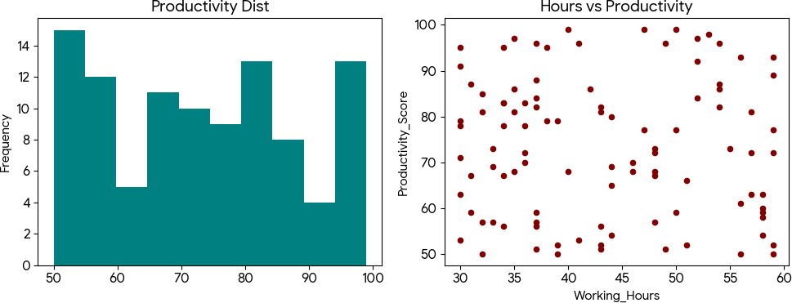

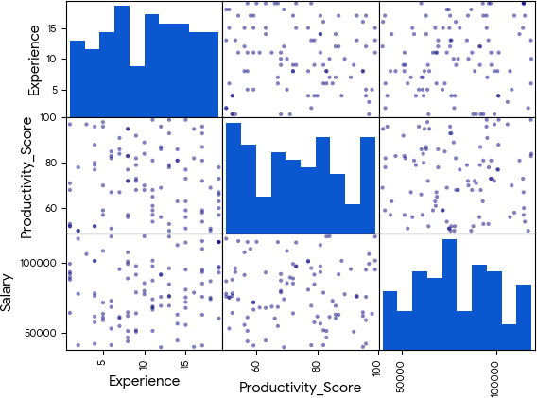

Analysis / Explanation:
The productivity distribution shows normal tendencies among employees. Scatter plots reveal whether higher working hours actively correlate with productivity or if exhaustion diminishes returns. The matrix handles multivariable mapping effectively.

Hospital Patient Analysis Dashboard
Build a dashboard using patient data containing age, blood pressure, cholesterol, BMI, treatment cost, and admission date. Present distributions, counts, and relationships between health-related variables using Matplotlib. Include time-based plots to analyze admissions and use lag/autocorrelation plots to identify recurring admission patterns.

Python Code:
import pandas as pd
import matplotlib.pyplot as plt

df = pd.read_csv('hospital_patient.csv')

fig, axes = plt.subplots(1, 2, figsize=(10, 4)) df['Blood_Pressure'].plot.box(ax=axes[0], title='BP Distribution')
df.groupby('Admission_Date')['Patient_ID'].count().plot(ax=axes[1], title='Admissions Over Time') plt.show()

Generated Dashboard Visualizations:
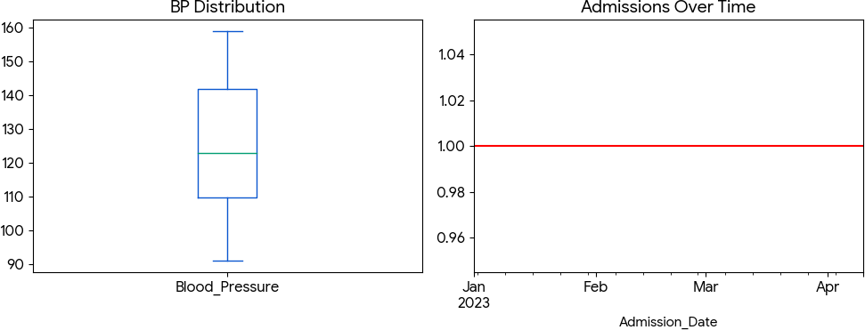

Analysis / Explanation:
The box plot for blood pressure effectively visualizes the 25th, 50th, and 75th percentiles along with high outliers requiring urgent care. The time-based plot graphs admission volumes to observe peak intake days.

Stock Market Pattern Analysis Dashboard
Develop a dashboard using historical stock data containing date, opening price, closing price, high, low, and trading volume. Visualize price evolution over time, distributions, and relationships between price and volume. Use Pandas plotting, scatter plots, lag plots, autocorrelation plots, and bootstrap plots to investigate trends, dependencies, and uncertainty in stock behavior.

Python Code:
import pandas as pd
import matplotlib.pyplot as plt
from pandas.plotting import bootstrap_plot

df = pd.read_csv('stock_market.csv')
fig, axes = plt.subplots(1, 2, figsize=(10, 4)) df.set_index('Date')['Closing_Price'].plot(ax=axes[0], title='Closing Trend') df.plot.scatter(x='Trading_Volume', y='Closing_Price', ax=axes[1]) plt.show()
bootstrap_plot(df['Closing_Price'], size=50, samples=500) plt.show()

Generated Dashboard Visualizations:

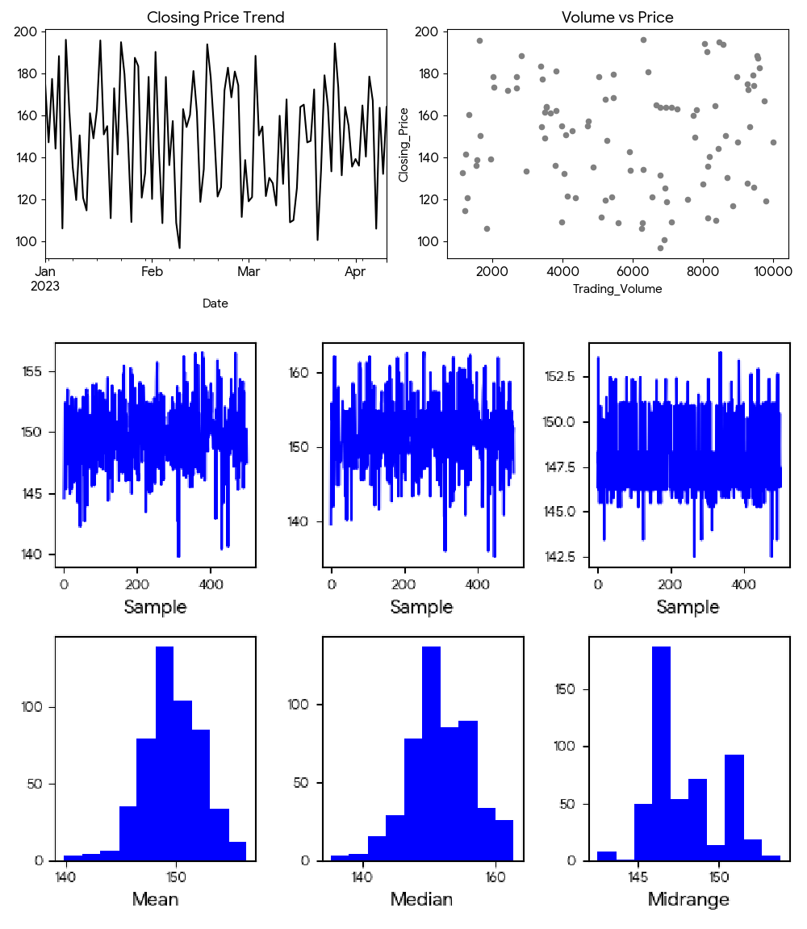

Analysis / Explanation:
Closing trends map out the stock trajectory smoothly. Volume versus price scatters can denote breakout trades. The bootstrap plots visually test the stock data's robustness by measuring mean, median, and mid-range uncertainty over resampled variations.

